**CHAPTER 1**

**INTRODUCTION**

A library Management system is software built to handle the primary housekeeping functions of a library. Library relies primarily on the library management systems to manage asset collections as well as relationships with their members. Library Management System helps libraries keep track of the books and their checkouts, as well as member subscriptions and profiles.

Library Management Systems also involves maintaining the database for entering new books and recording books that have borrowed with their respective due dates. The system should be easy to use and should fulfill all the requirements of a librarian. There are many features which helps the librarian to keep records of available books as well as issued books. This software must provide both local host as well as web based.

**Advantages**

* The system excludes the use of paper work by managing all the book information electronically.
* Admin can keep updating the system by providing the new books arrival in system and their availability thus students need not to go to library for issuing purpose.
* The system has books well organized and systematically arranged in different categories in the system so that user can easily search and find the book.
* Thus, it saves human efforts and resources.

**Disadvantages**

* There is no human interaction if users have some enquiry.

**CHAPTER 2**

**REQUIREMENT SPECIFICATION**

The hardware and software components of a computer system that are required to install and use software efficiently are specified in the SRS. The minimum system requirements need to be met for the program to run at all times on the system.

**2.1 HARDWARE SPECIFICATION**

The hardware’s used for development of the project are:

* Processor :Core™ i7 2.6 GHZ
* RAM :16 GB DDR4 RAM
* Monitor :15.6’’ LED
* Storage :512 GB Solid State Drive
* Keyboard :STANDARD 102 KEYS

**2.2 SOFTWARE SPECIFICATION**

The software’s used for development of the project are:

* Operating System: Windows 10, MacOS 10.15
* Backend Software: ORACLE 10G EXPRESS EDITION

**CHAPTER 3**

**DESCRIPTION**

A library management is a project that manages and stores books information electronically according to student’s needs. The system helps both students and library manager to keep a constant track of all the books available in the library. It allows both the admin and the student to search for the desired book. It becomes necessary for colleges to keep a continuous check on the books issued and returned. This task if carried out manually will be tedious and includes chances of mistakes. These errors are avoided by allowing the system to keep track of information such as issue date, last date to return the book and thus there is no need to keep manual track of this information which thereby avoids chances of mistakes. Thus this system reduces manual work to a great extent allows smooth flow of library activities by removing chances of errors in the details.

A database is a structured collection of data .Data refers to the characteristics of people, thing and events. A database management system, or DBMS, gives the user access to their data and helps them transform data into information .Such database management systems include dBase, paradox, IMS, SQL Server and MySQL. These systems allow users to create, update and extract information from their database. Different tables are created for the various groups of information. Related tables are dropped to the form a database. This project has been designed using Oracle 10g XE.

**3.1. ORACLE**

Oracle Corporation has been periodically introducing advanced database technology directing all of its resources toward developing the design, management and implementation of client/server database components the primary components are:

A full-featured, high performance RDBMS server.

Client development and runtime products that support multiple cui environments. Database connectivity middleware that provides efficient and secure communication over a wide variety of network protocols. Oracle also contains the following language based features that serve to accelerate development and improve the performance of application components.

PL/SQL language

Stored Procedures

The oracle is organized in four layers as shown below. The kernel provides communication with database and the connection with the other kernels in a distributed database environment.

Data dictionary provides the details of the database objects such as Tables, Columns, and Views etc., the oracle users, the rights and privileges of the objects.

The dictionary is made up of Tables and views. They are created at the time of oracle installation and are manipulated through SQL by oracle. The tables in the dictionary are not accessible by the user to maintain integrity of the database.

**3.1.1. ORACLE 10G XE**

Oracle Database 10 Express Edition (Oracle Database XE) is a free version of the world's most capable relational database. With Oracle Database 10g XE, you use an intuitive, browser-based interface, to:

* Administer the database
* Create table, views, and other database object Import, export, and view table data
* Run queries and SOL script.
* Generate reports.

**3.2 STRUCTURED QUERY LANGUAGE (SQL)**

SQL (pronounced SEQUEL) is the programming language that defines and manipulates the database. SQL databases are relational databases; this means simply that data is stored in a set of simple relations. A table that has an employee database, for example, might have a column called employee number and each row in that column would be an employee’s employee number.

You can define and manipulate data in a table with SQL commands. You use data definition language (DDL) commands to set up the data. DDL commands include commands to creating and altering databases and tables.

You can update, delete, or retrieve data in a table with data manipulation commands (DML). DML commands include commands to alter and fetch data. The most common SQL command is SELECT command, which allows you to retrieve data from the database.

In addition to SQL commands, the oracle server has a procedural language called PL/SQL. PL/SQL enables the programmer to program SQL statements. It allows you to control the flow of a SQL program, to use variables, and to write error-handling procedures.

SQL is a non-procedural language because it processed set of records rather than just one data at a time and also provides automatic navigation to the data. Here one can manipulate a set of rows rather than one at a time. SQL commands accept set of rows as input and return sets of output. The set property of SQL allows the results of one SQL statement to be used, as input to another; here one need not specify the access method of the data.

SQL is utilized as the communication language with the database among the database users like database administrators, security administrators, application programmer, SQL provides commands for a variety of tasks including

* Inserting, updating and deleting rows in an object
* Creating, replacing, altering and dropping objects
* Controlling access to the database and its objects
* Guaranteeing database consistency and integrity

**3.3. ER DIAGRAM**

An entity-relationship model (ER model) is a data model for describing the data or information aspects of a business domain or its process requirements, in an abstract way that lends itself to ultimately being implemented in a database such as a relational database. The main components of ER models are entities (things) and the relationships that can exist among them. Entity-relationship modeling was developed by Peter Chen and published in a 1976 paper. The ER diagram is drawn to have a better understanding of the whole scenario, it is used to conceptualize the phenomena, actions and interactions between various entities and to arrive at the specific requirements in a comprehensive manner.

An entity-relationship model is the result of using a systematic process to describe and define a subject area of business data. The data is represented as components (entities) that are linked with each other by relationships that express the dependencies and requirements between them, such as: one building may be divided into zero or more apartments, but one apartment can only be located in one building. Entities may have various properties (attributes) that characterize them. Diagrams created to represent these entities, attributes, and relationships graphically are called entity relationship diagrams. An ER model is typically implemented as a database. In the case of a relational database, which stores data in tables, every row of each table represents one instance of an entity. Some data fields in these tables point to indexes in other tables, such pointers are the physical implementation of the relationships The three schema approach to software engineering uses three levels of ER models that may be developed.

A relationship captures how entities are related to one another. Relationships can be thought of as verbs, linking two or more nouns. Examples: An own relationship between a company and a computer, a supervised relationship between an employee and a department, a performs relationship between an artist and a song relationship between a mathematician and a conjecture. Entities and relationships can both have attributes Examples: an employee entity might have a Social Security Number (SSN) attribute, the proved relationship may have a date attribute.

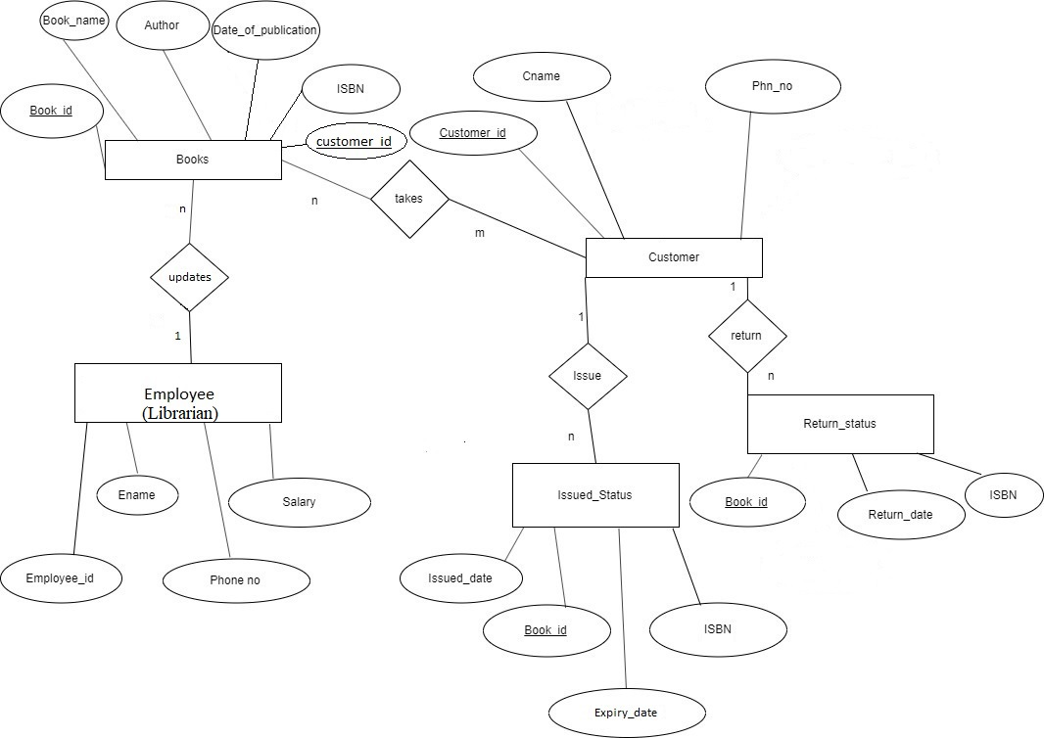

Fig 3.1:- Entity-Relationship Model for Library Management System

**3.4. SCHEMA DIAGRAM**

A schema diagram is the skeleton structure that represents the logical view of the entire database. It defines how the data is organized and how the relations among them are associated. It formulates all the constraints that are to be applied on the data.

A Database schema defines its entities and the relationship among them. It contains a descriptive detail of the database, which can be depicted by means of schema diagrams. It’s the database designers who design the schema to help programmers understand the database and make it useful.

A database schema can be divided broadly into categories –

* **Physical Database Schema** – This schema pertains to the actual storage of data and its form of storage like files, indices etc. It defines how the data will be stored in a secondary storage.
* **Logical Database Schema** – This schema defines all the logical constraints that need to be applied on the data stored. It defines tables, views and integrity constraints.

Database schema is the skeleton of the database. It is designed when the database doesn’t exist at all. Once the database is operational, it is very difficult to make any changes to it. A database schema does not contain any data or information.

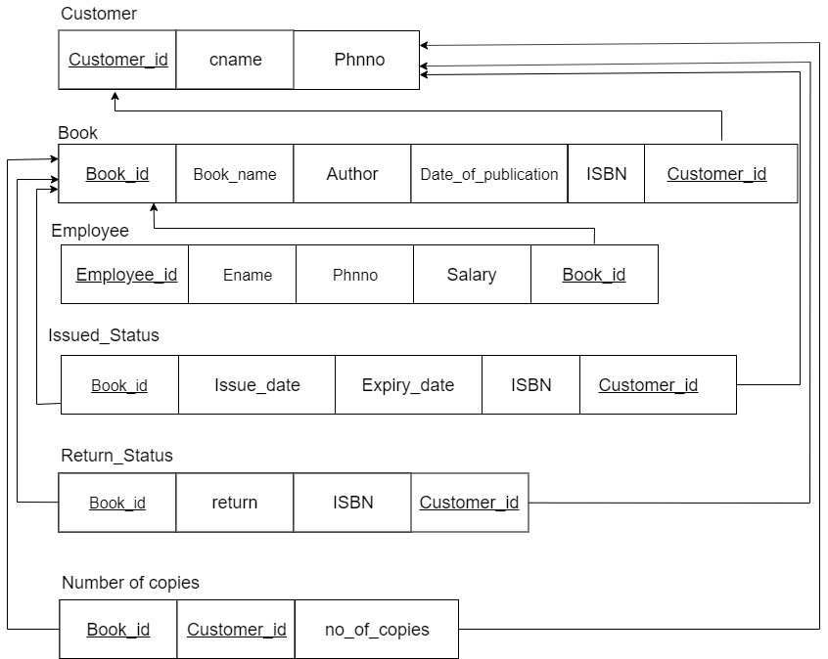

Fig 3.2:- Relational schema generated from the ER Diagram

**CHAPTER 4**

**CODING**

**CREATE TABLES:**

create table customer (

customer_id int primary key,

cname varchar(20),

phn varchar(20)

);

create table book (

book_id int primary key,

book_name varchar(20),

Author varchar(20),

Date_of_publication date,

ISBN int,

customer_id int references customer(customer_id)

);

create table employee (

employee_id int,

Ename varchar(20),

phn varchar(20),

salary real,

book_id int references book(book_id)

);

create table issue_status (

Book_id int references book(book_id),

issue_date date,

expiry_date date,

ISBN int,

customer_id int references customer(customer_id)

);

create table return_status (

book_id int references book(book_id),

return_date date,

ISBN int,

customer_id int references customer(customer_id)

);

create table no_of_copies (

book_id int references book(book_id),

customer_id int references customer(customer_id),

no_of_copies int

);

**INSERTION OF VALUES:**

insert into customer values (301,'Ronaldo','8088943667');

insert into customer values (302,'Messi','8088943667');

insert into customer values (304,'Hazard','8088943667');

insert into customer values (305,'Aguero','8088943667');

insert into customer values (300,'Malika','8088943667');

insert into book values (132,'Game of Thornes','Abyakta Koirala','01-aug-1996',101,301);

insert into book values (133,'Harry Potter','Aditya Rouniyar','26-jun-1997',102,302);

insert into book values (134,'Crimes of Grindwald','Aditya Rouniyar','13-nov-2018',106,302)

insert into book values (146,'The Witcher','Pragik Timsina','06-nov-2013',103,304);

insert into book values (156,'Lord of the Rings','Sandesh Kafle','29-jul-1954',104,305);

insert into book values (273,'The Alchemist','Ashish Sah','23-nov-1988',105,300);

insert into employee values (001,'Kunal','9861445230',20000,132);

insert into employee values (002,'pankaj','9860080153',35000,146);

insert into employee values (003,'bishwas','9851007837',10000,133);

insert into employee values (004,'anjan','9861444235',18000,156);

insert into employee values (005,'ankit','9841535203',2000,273);

insert into employee values (005,'ankit','9841535203',2000,134);

insert into issue_status values (132,'09-nov-2019','19-nov-2019',101,301);

insert into issue_status values (133,'06-oct-2019','16-oct-2019',102,302);

insert into issue_status values (134,'06-oct-2019','16-oct-2019',106,302);

insert into issue_status values (146,'08-oct-2019','18-oct-2019',103,304);

insert into issue_status values (156,'08-oct-2019','18-oct-2019',104,305);

insert into issue_status values (273,'09-oct-2019','19-oct-2019',105,300);

insert into return_status values (132,'17-nov-2019',101,301);

insert into return_status values (133,'16-oct-2019',102,302);

insert into return_status values (134,'14-oct-2019',106,302);

insert into return_status values (146,'12-oct-2019',103,304);

insert into return_status values (156,'10-oct-2019',104,305);

insert into return_status values (273,'18-oct-2019',105,300);

insert into no_of_copies values (132,301,6);

insert into no_of_copies values (133,302,2);

insert into no_of_copies values (134,302,12);

insert into no_of_copies values (146,304,3);

insert into no_of_copies values (156,305,2);

insert into no_of_copies values (273,300,5);

**CHAPTER 5**

**SNAPSHOTS**

**TABLE DESCRIPTIONS:**

**CUSTOMER:**

Desc customer;

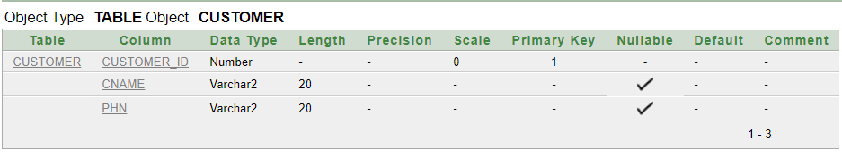

**BOOK:**

Desc book;

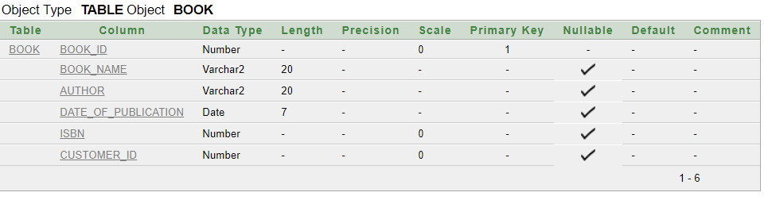

**EMPLOYEE:**

Desc employee;

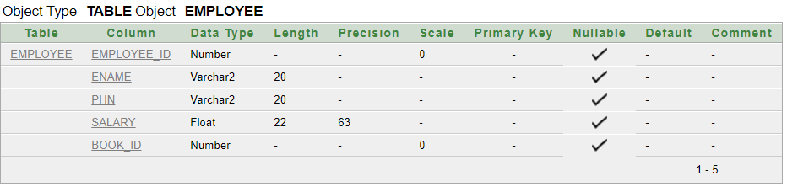

**ISSUE_STATUS:**

Desc issue_status;

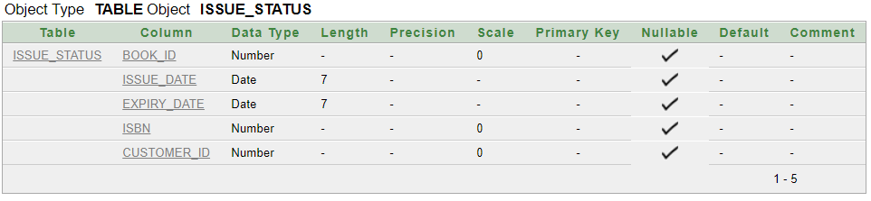

**RETURN_STATUS:**

Desc return_status;

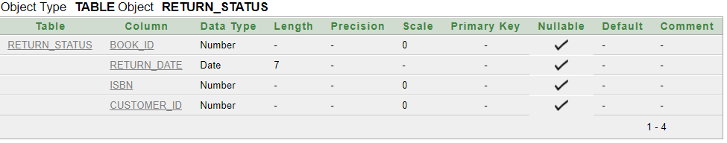

**NO_OF_COPIES:**

Desc no_of_copies;

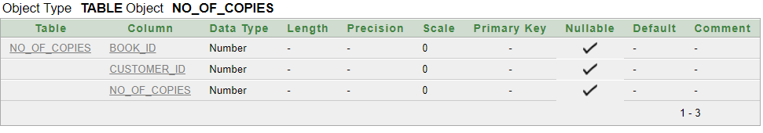

**TABLES:**

**CUSTOMER:**

Select * from customer;

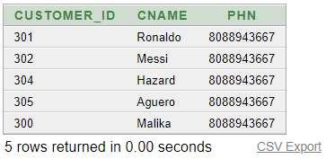

**BOOK:**

Select * from book;

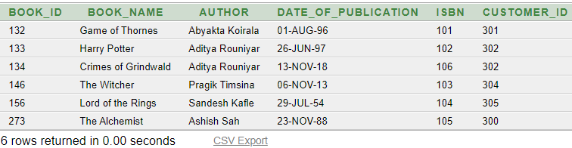

**EMPLOYEE:**

Select * from employee;

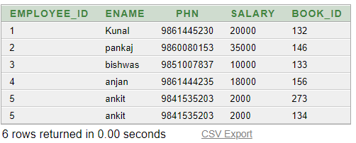

**ISSUE_STATUS:**

Select * from issue_status;

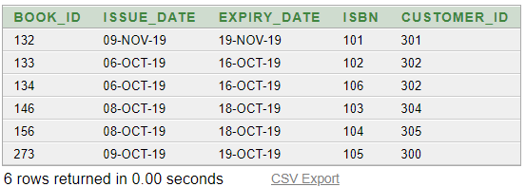

**RETURN_STATUS:**

Select * from return_status;

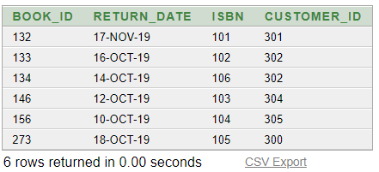

**NO_OF_COPIES:**

Select * from no_of_copies;

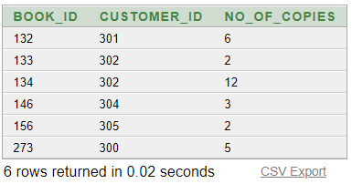

###### **QUERIES**

**1) Write the book name, customer name of the books that starts with "T"?**

select book_name,cname

from book b,customer c

where c.customer=b.customer_id and book_id in (select book_id

from book

where book_name LIKE 'T%');

**OUTPUT:**

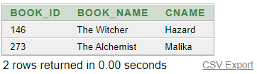

**2) Find the return date of the book of the customer Messi?**

select return_date

from return_status

where book_id in (select book_id

from customer c, return_status r

where c.customer_id=r.customer_id

and cname='Messi');

**OUTPUT:**

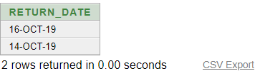

**3)Find the customer name with issue date and return date of the books who's number of copies is greater than 5?**

select issue_date,expiry_date,cname

from customer c,issue_status i

where c.customer_id=i.customer_id and book_id in (select book_id

from no_of_copies

where no_of_copies>5);

**OUTPUT:**

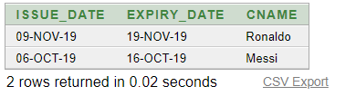

**4) Find the name of employee who provided customer the books with customer name?**

select c.cname

from customer c,book b

where b.customer_id = c.customer_id

and b.book_id in (select distinct b.book_id

from book b,customer c

where b.customer_id=b.customer_id

and b.book_id in(select book_id

from employee

where Ename = 'ankit'));

**OUTPUT:**

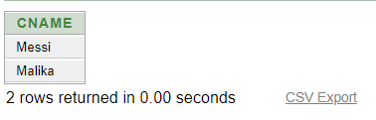

**5)Find the number of customer who have reserved books written by author Aditya Rouniyar?**

select count(*)

from customer c,book b

where c.customer_id=b.customer_id

and b.author='Aditya Rouniyar';

**OUTPUT:**

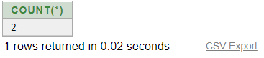

**6) Find the the name of customer who have to return the books on 15 october and 18 october along with the book name?**

select cname,book_name

from customer c,book b,issue_status i

where (i.expiry_date between '15-oct-2019'and '18-oct-2019')

and c.customer_id=b.customer_id

and b.book_id=i.book_id;

**OUTPUT:**

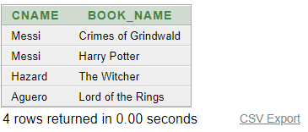

**7) Find the customer who doesn't get book issued by ankit?**

select cname

from customer

where cname not in (select cname

from employee e, book b, customer c

where e.book_id=b.book_id and c.customer_id=b.customer_id and e.ename='ankit');

**OUTPUT:**

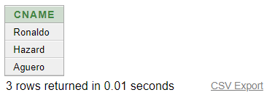

**CONCLUSION**

Library Management is for computerizing the working in a library. It is a great improvement over the manual system. The computerization of the system has speed up the process. The library management system was thoroughly checked and tested with dummy data and thus found to be reliable. The system takes the maximum care of all the requirements of an average library and is capable to provide easy and effective storage of information related to users that come up to the library. It generates user details and also with the number of books issued by the user and also tells us that the user has returned the book or not.

In conclusion, this project also aims to satisfy each and every user, as user satisfaction is the most important of all .To wind up, let me welcome all the suggestion and other improvement, which the system needs so that it covers all the needs of the user in any manner possible.

**BIBLIOGRAPHY**

**BOOK**

* Fundamental of Database system by Elmasri and Navathe. 5th Edition. Addison-Wesley,2007.

**URL**

* [www.google.com](http://www.google.com)
* www.draw.io
* [www.youtube.com](http://www.youtube.com)
* [www.wikipedia.org](http://www.wikipedia.org)
* [www.techonthenet.com/sql/](http://www.techonthenet.com/sql/)